14.E-COMMERCE REGIASTRATION SYSTEM

ACTIVITY DIAGRAM

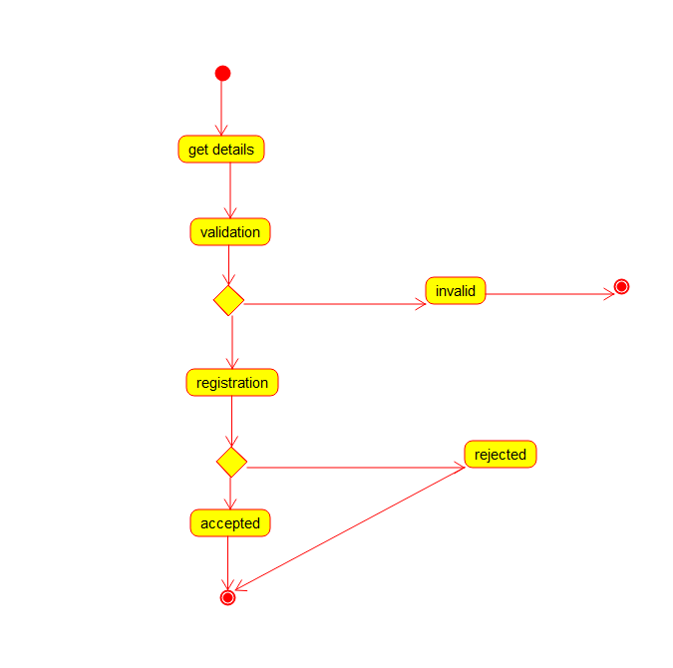

CLASS DIAGRAM

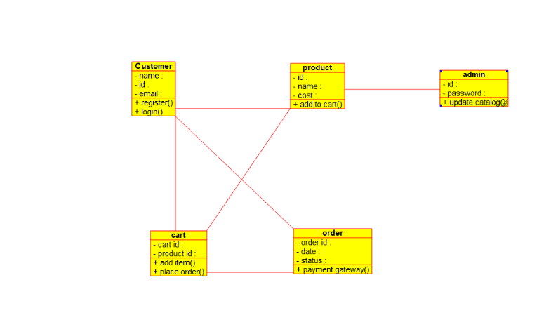

USECASE DIAGRAM

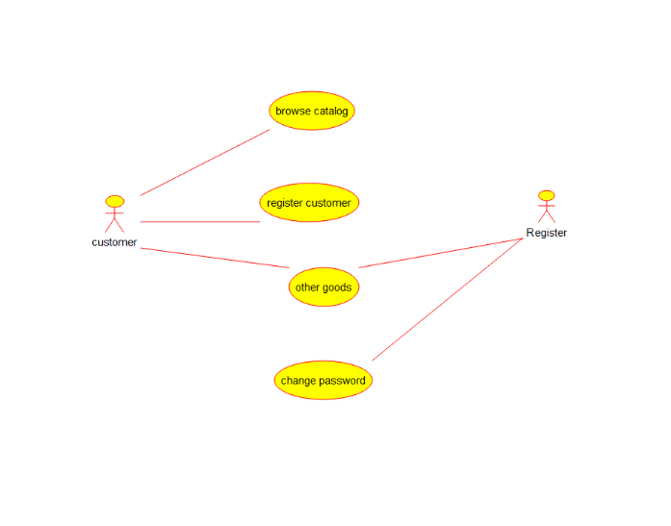

SEQUENCE DIAGRAM

